**S-HIS Summary for Science Flight #6, September 16 – 17 2014**

Science Flight #7 was primarily a set of repeated crossings over the center of Hurricane Edouard. Much of the area to the west and north of the storm was partly cloudy, so the real time temperature and water vapor profile retrievals were rarely reaching the surface. To the southeast of the storm, the area was quite clear, and the retrieved humidity profile shows moderate moisture levels (~50% RH) to 600 hPa. Figure 1 shows the RH cross section east of the storm, between eye passes 6 and 7.

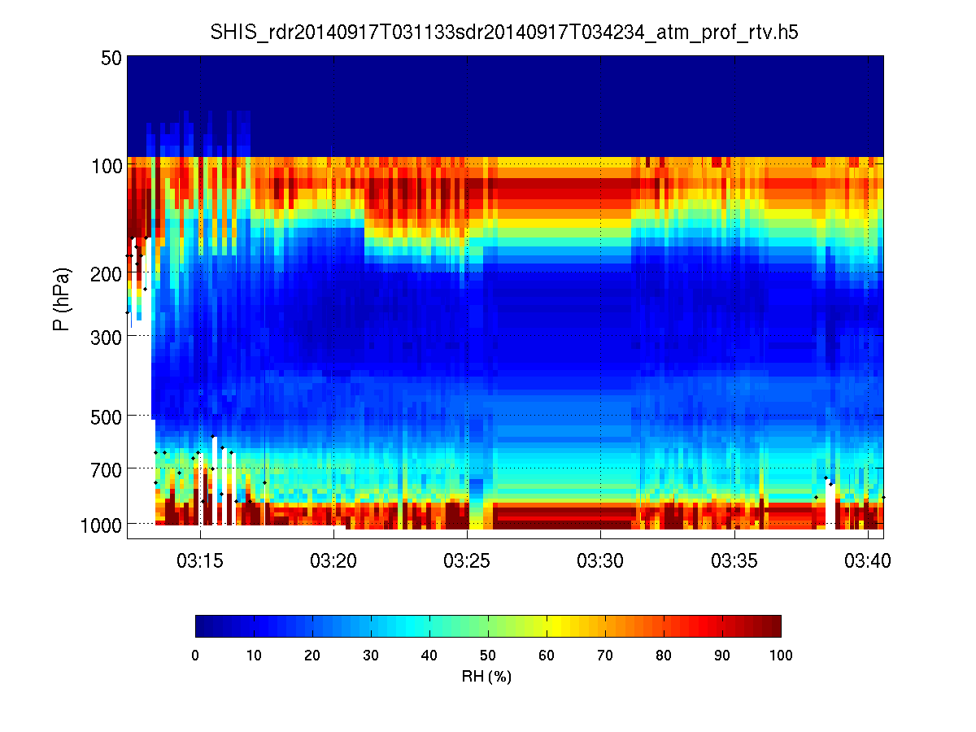

**Figure 1.** RH cross section to the east of Edouard.

During the eye approaches, the S-HIS data was used to help determine with the aircraft passed over the eyewall, to help time the dropsonde release. The brightness temperature swath display was also used to help evaluate the track positioning for each path after each crossing. Figure 2 shows a summary of eye passes 1 through 6 with a 200 – 300 K display range. This summary plots a portion of the S-HIS swath, all in the same latitude longitude grid, to show the path of the storm center. The eye shows varying degrees of cloud cover in the center.

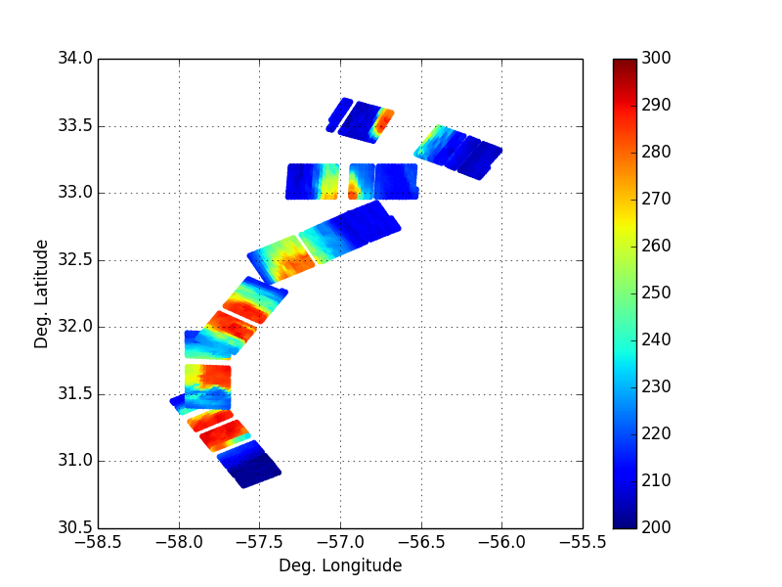

**Figure 2.** Collage of eye passes 1 – 6 as seen in the S-HIS swath.