S-HIS Flight Summary: 16-17 September 2013
J. Gero, D. Tobin, University of Wisconsin–Madison, SSEC
Summary
The Global Hawk overflew tropical storm Humberto during at 20.5 hour science flight. Several multilayered clouds were observed during flight giving a nice comparison between the realtime products and quicklooks of S-HIS and CPL. Additionally, the S-HIS realtime retrievals had good agreement with major features of the AVAPS dropsondes during the flight. SAL air was indicated in the SE corner of the flight pattern.
The S-HIS operated nominally throughout the science flight. The detector cooler stayed around 77 K for the duration of the mission.
Timeline (All times are UTC and are only approximate):
- 20130916T1333 GH engine start
- 20130916T1433 SHIS Power on
- 20130916T1441 Takeoff
- 20130917T0931 S-HIS descent heaters on
- 20130917T0936 Instrument power OFF before descent (IL42, IL41, DC41, DC42)
- 20130917T1004 Instrument power ON (DC41, DC42, IL41, IL42)
- 20130917T1042 Instrument power OFF (IL42, IL41, DC41, DC42)
- 20130917T1114 Landing

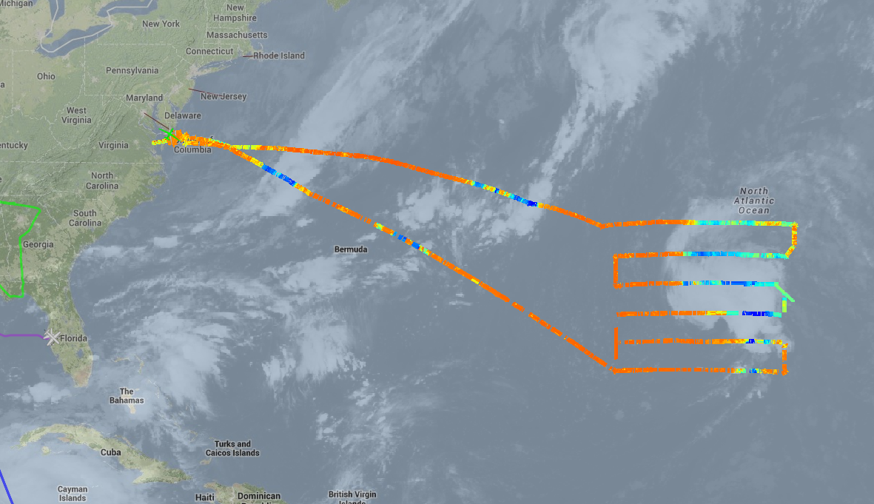
Figure 1. Flight overview, overflight of tropical storm Humberto.
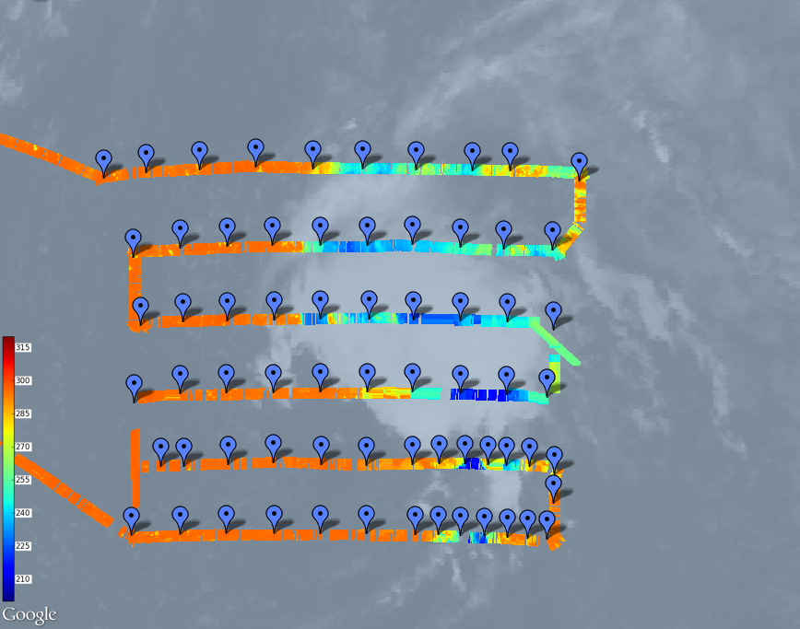
Figure 2. S -HIS realtime brightness temperature data in the 895–905 cm⁻¹ channel for the entire science segment of the flight, superimposed on the current GOES IR image. Dropsonde locations are indicated in blue.
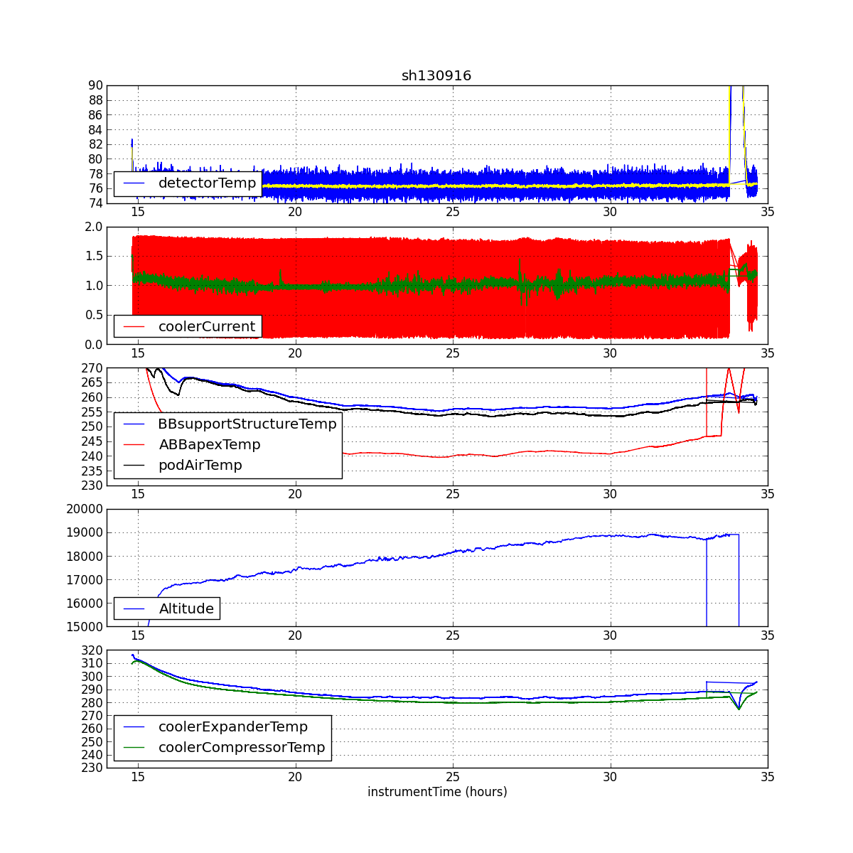
Figure 3. The detector cooler operated nominally during the science flight. Detector temperature was at around 77 K throughout the flight. Cooler current was around 1 Amp throughout the flight.
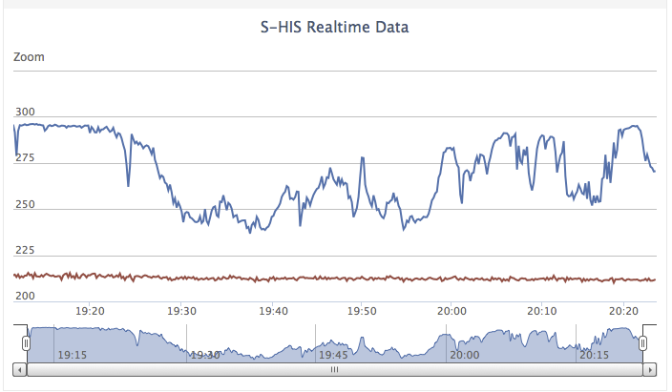
Figure 4. A new data display showing time series of realtime S-HIS brightness temperatures is being tested. 895-905 cm⁻¹ (blue) and 690-700 cm⁻¹ (red) channels are shown above.

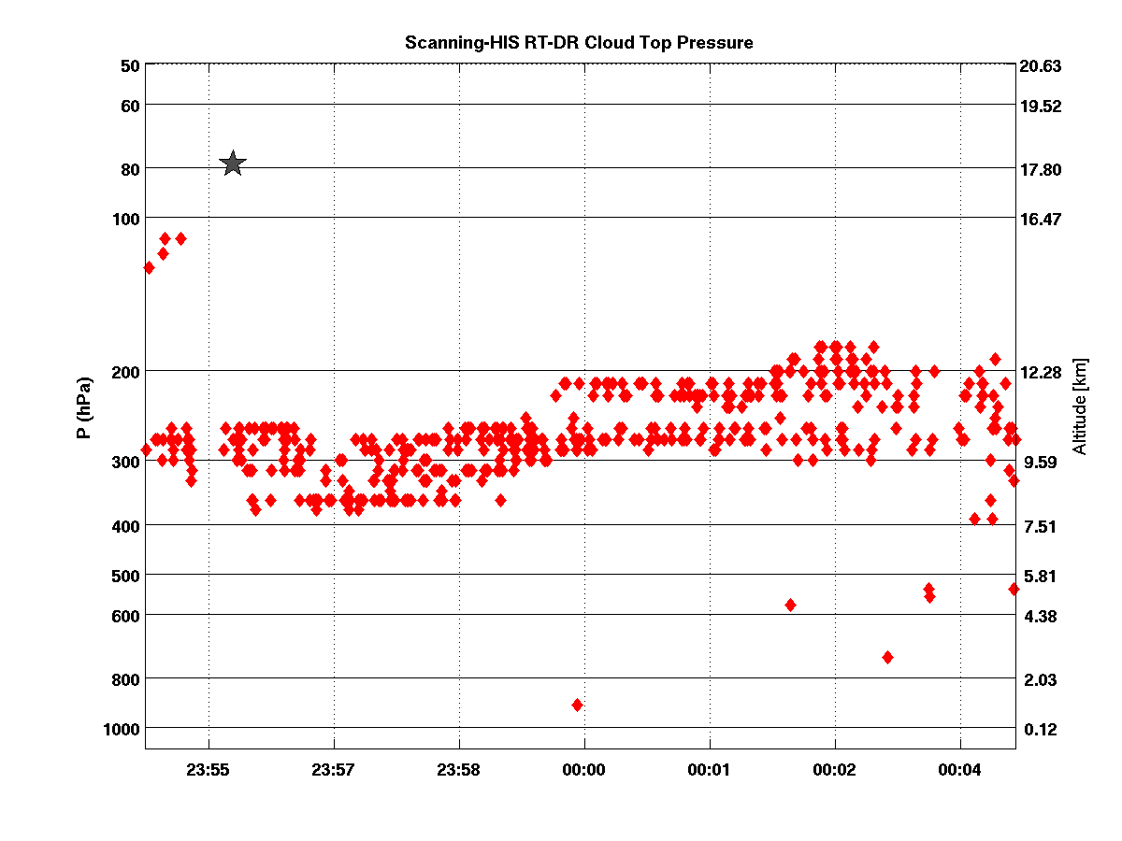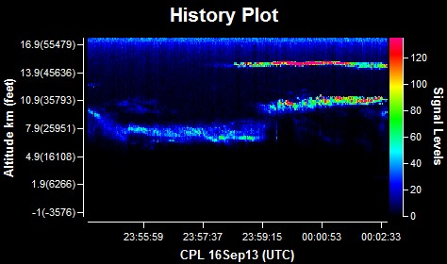
Figure 5. Comparison between S-HIS RT-DR quicklook time series (left) and CPL quicklook time series (right) showing some interesting cloud layers. The RT-DR plot shows both pressure altitude and altitude in km as the y-axes. The star indicates the aircaft altitude. The RT-DR shows similar cloud heights as the CPL for the two lower cloud layers, but is not seeing the higher (most likely thinner) layer at ~15 km.
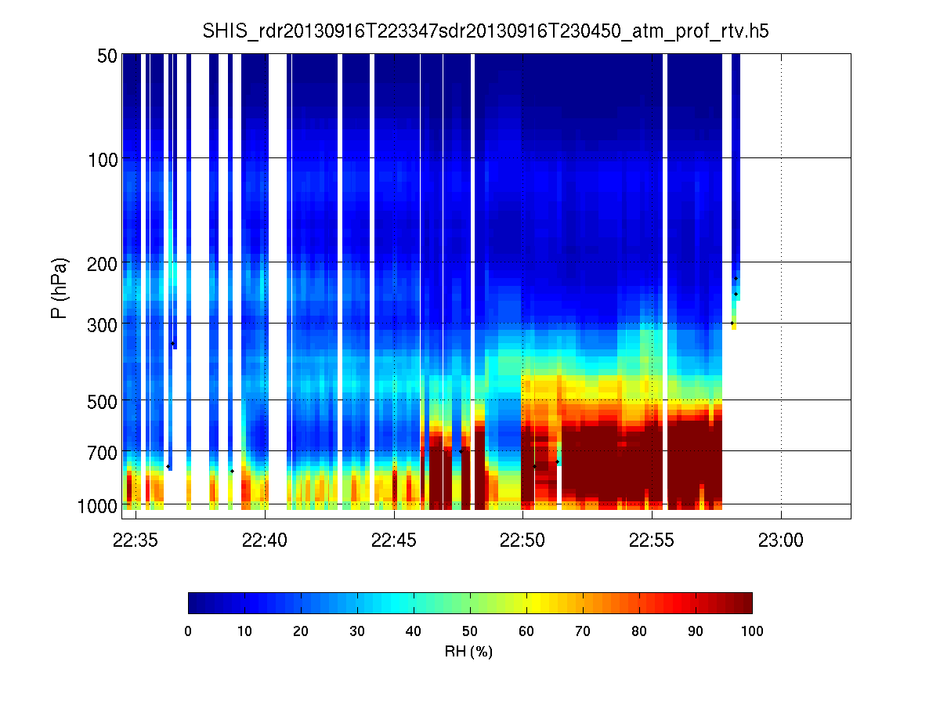
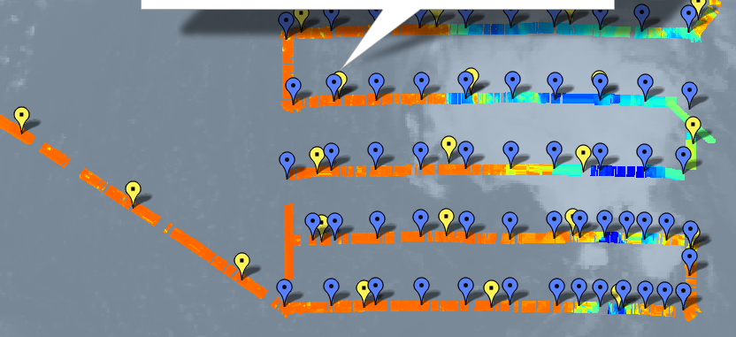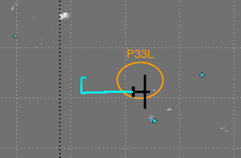

Figure 6. S-HIS RH cross seciton going west to east across Pouch 33L, showing lower levels much moister within the pouch, and a very definite RH change at the pouch boundary. Further east it gets much cloudier and S-HIS does not see through the clouds.

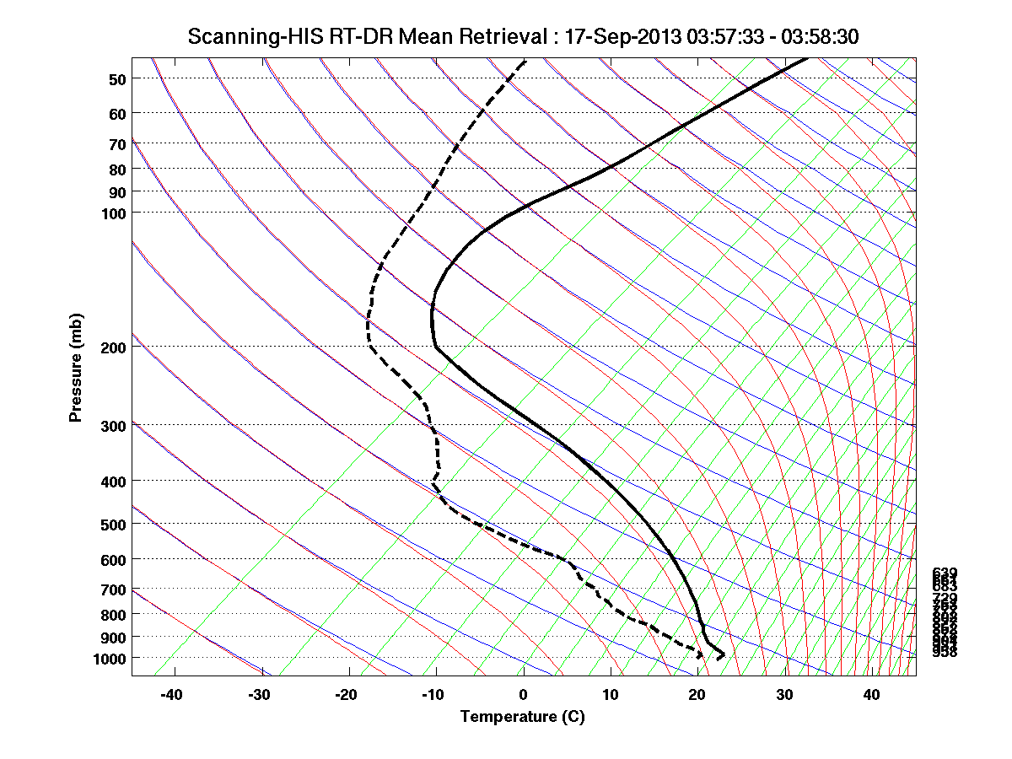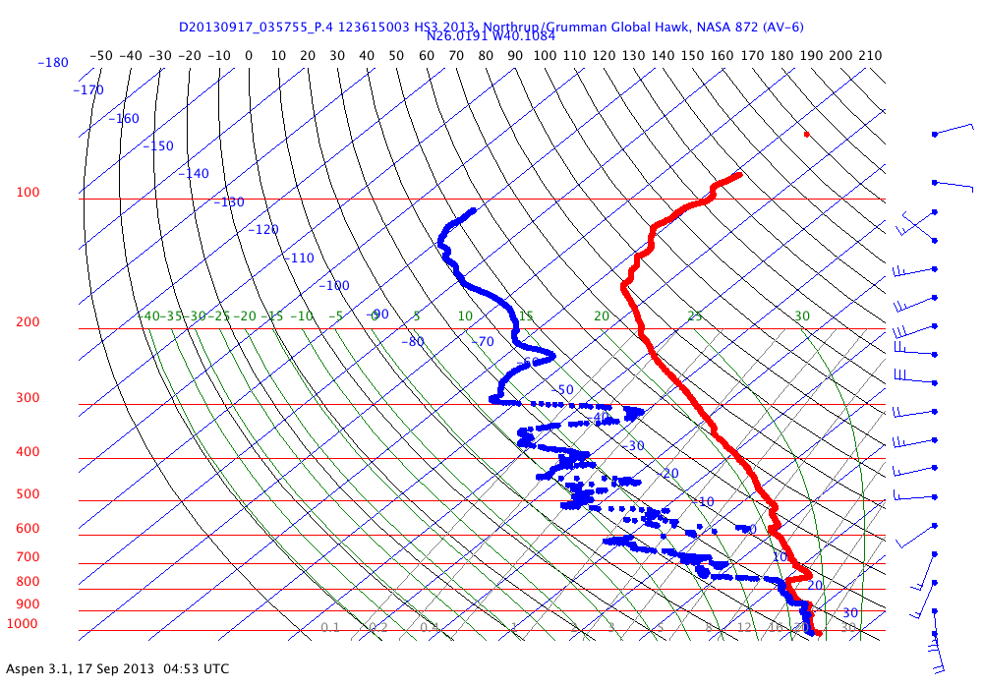
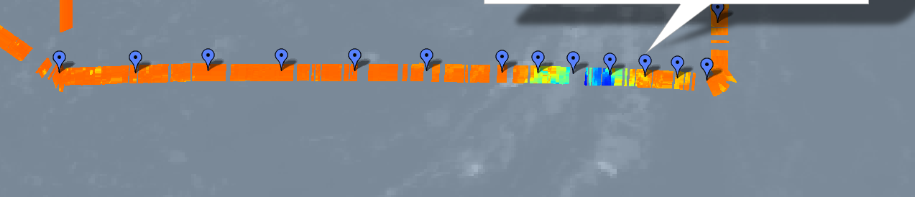
Figure 7. Relatively good agreement between SHIS temperature and moisture structure (left) with the dropsonde profiles (right). This comparison is in the SE corner of the flight where the SAL was encountered.

