**S-HIS Flight Summary: 24-25 August 2013**

Revision: 25 August 2013, R. Knuteson, University of Wisconsin-Madison, SSEC

**Summary:**

Nominal operation. No problems encountered. Ku lost in southernmost flight legs however complete SHIS data will be available in post-processed products. New “Half-Hour Summary” cross-section plots available on MTS under aircraft payload.

This was an excellent SAL flight with validation data from AVAPS dropsondes and CPL lidar with exciting dust “jet” cross-sections. Example quicklooks provided below illustrate that the S-HIS T/WV retrievals are capturing the moistening near the top of the dust layer (about 600 mb) validated by the dropsondes.

**Timeline (All times are UTC and are only approximate):**

* 20130824T1055 SHIS power ON prior to takeoff
* 20130824T1058 Takeoff
* 20130825T1001 Descent heaters ON
* 20130825T1105 Instrument power OFF
* 20130825T1134 Landing

**SAL Region Sounding Comparison SHIS and Dropsonde: 20130824 22:12:17 UTC**

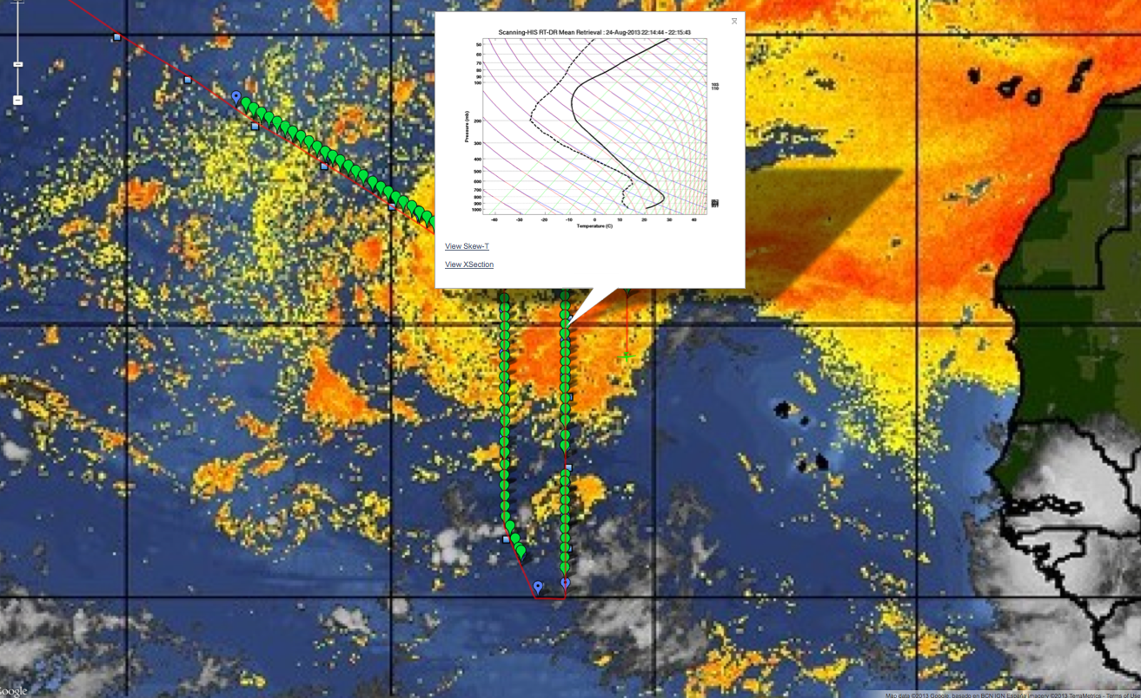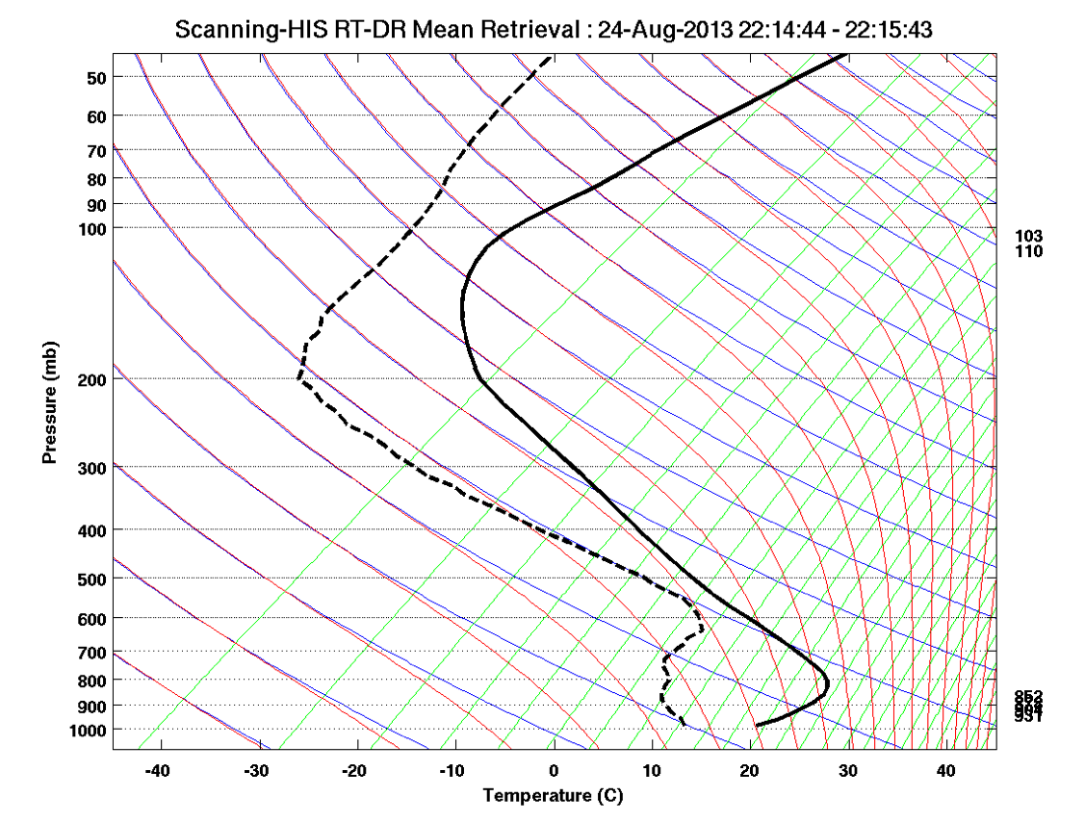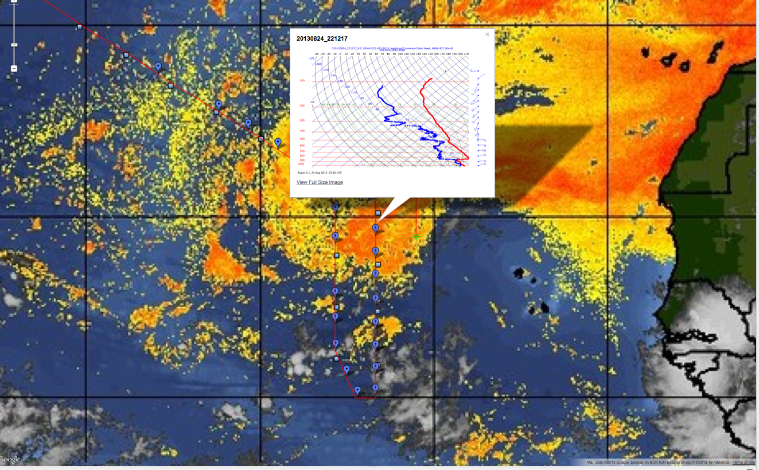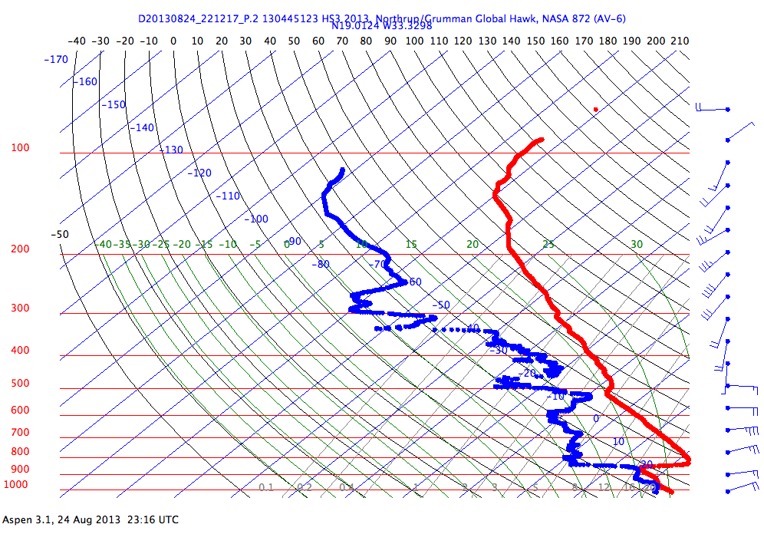

**S-HIS Retrieval: RH time-height cross-section Quicklook Example from MTS (1 hour latency)**

