**S-HIS Flight Summary: 20-21 August 2013**

Revision: 21 August 2013, R. Knuteson, University of Wisconsin-Madison, SSEC

**Summary:**

Nominal operation. No problems encountered. Real-time retrievals available on MTS.

**Timeline (All times are UTC and approximate):**

* 20130820T1237 SHIS power ON prior to takeoff
* 20130820T1242 Takeoff
* 20130820T2247 SHIS power OFF requested by PM inflight to diagnose AVAPS
* 20130820T2308 SHIS power ON
* 20130820T2320 SHIS detector at 78 K. Back to normal operation.
* 20130821T1208 Descent heaters ON
* 2013082110223 Instrument power OFF before descent
* 2013082110243 Instrument power ON
* 2013082110306 Instrument power OFF
* 2013082110347 Landing

**S-HIS Quicklook BT Map for flight 20130820 at 11 microns (985-905 cm-1)**

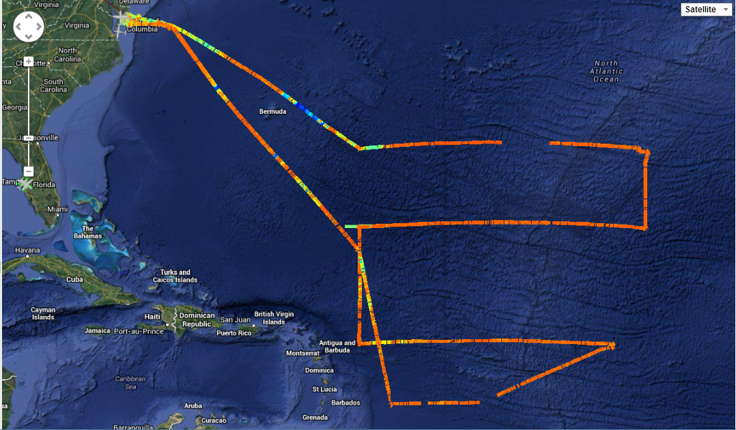

**S-HIS Retrieval: SkewT Quicklook Example**

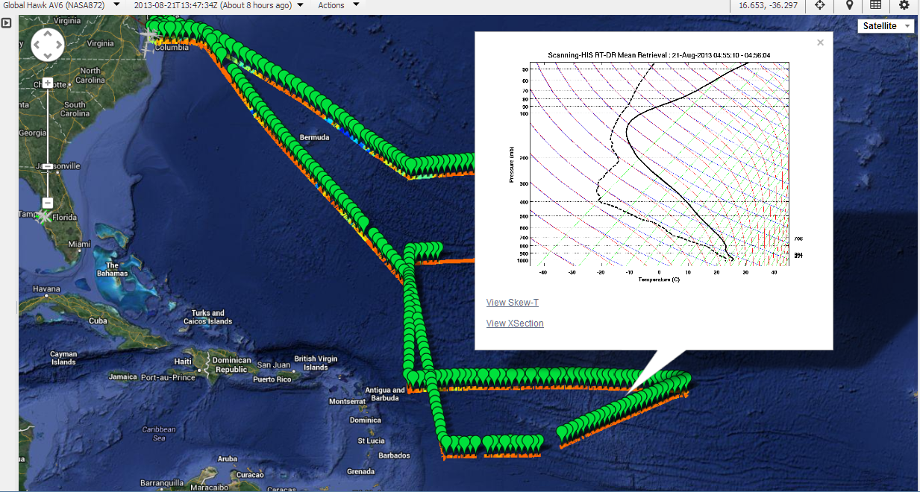

**S-HIS Retrieval: RH x-section Quicklook Example: 3rd leg West to East into SAL at 17.4 North Latitude**

